YOUR AMERICAN GUT SAMPLE

What’s in your American Gut sample?
Taxonomy | Sample | Population | Fold
cont. Genus Eubacterium | 1.23% | 0.29% | 4x
cont. Genus Ruminococcus | 6.51% | 0.72% | 9x
Order RF32 | 2.69% | 0.40% | 7x
Order RF39 | 4.40% | 0.55% | 8x
Taxonomy | Sample
Genus Bacteroides | 20.7%
Family Ruminococcaceae | 9.5%
Genus Ruminococcus | 8.7%
Family Lachnospiraceae | 7.8%
Your most abundant microbes: Your most enriched microbes:
100
Firmicutes
Bacteroidetes
Proteobacteria
Actinobacteria
Verrucomicrobia
Tenericutes
Cyanobacteria
Fusobacteria
Other
0
20
40
60
80
Frequency
Similar BMI
Same Gender
Similar Age
Similar Diet
Average
Your Sample
Michael Pollan
Your sample contained 7 rare taxa, including the following: Genus Sanguibacter, Genus Virgibacillus, Genus Rummeliibacillus, Genus Pediococcus, Genus Pseudoramibacter-Eubacterium.
How do your gut microbes compare to others? Your sample is here Others Unspecified
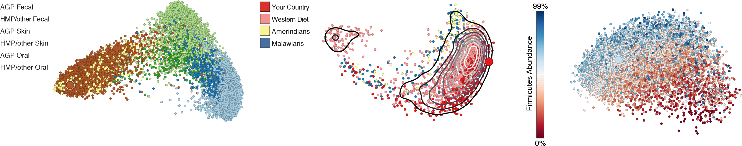
Different Body Sites Different Nationalities The American Gut Population

